**Application**

I applied online. The process took 2 weeks. I interviewed at DISH (Christiansburg, VA) in Jan 2023

**Interview**

phone screen, then 30 min hiring manager interview, then 1hr 2eng + hiring manager interview, then an online aptitude test (with questions about percentages, calendars, and spatial recognition, nothing to do with coding) and a personality test. The interviewers were nice, and the process moved quickly. The recruiter would call either the same day or the next to schedule the next part of the interview.

**Interview Questions**

* phone screen: Name a time when you displayed: energy, intelligence, or the need to achieve Name a time when you displayed: curiosity, pride, adventure, or winning. Why do you want to work here? What is your salary expectation? Panel: What is the DOM and what is its purpose in React? What is the difference between rebase and merge on git? What is the difference between an arrow function and a regular function? What is the difference between Redux and state in React? and why would you want to use one over the either? What is the difference between null, undefined, and undeclared? What would log on the console if you declared a variable with var and then changed it and called it again. (not exactly what the question was but its a good jumping off point to study) How do you declare an object in typescript? If someone told you to rewrite a feature you spent a long time on, how would you handle that or go about that? How do you go about debugging, what is your process? Name a time when you had to debug. -one easy leetcode problem where the hiring manager said it wasn't about solving it, just to see my thought process

I had an interview screening with the Software Engineering manager for one of the teams mainly located in Utah. Screening went well. I was asked some basic C++ questions and told they would reach put for a final interview.

**Interview Questions**

* Difference between a reference and a pointer.

Coding questions were on string, array and other basic DS.

What was my experience in C# and SQL?

Tell us about a project where you applied our company's values. These values are curiosity, pride, adventure, and winning.

I applied through a recruiter. The process took 1 week. I interviewed at DISH (Denver, CO) in Jun 2018

**Interview**

Initial phone screen was some typical "tell me about your history" stuff. I was then informed that I would be given a quantitative and reading comprehension exam. It was pretty easy stuff...a lot of percentages. I know I did well here because it was not difficult. At least, there's no way I did poorly. The reading comprehension was stupid, flat out. The next steps were to be an at home programming assignment and then a discussion around it. We never got here. Strange. I got the impression that they had me waste 2 hours on the test when based on my resume alone, they weren't going to consider me. So unfortunately this was likely a waste of time from the beginning. If your resume is an exact fit for the role you applied for you may have better luck. If you don't have a perfect fit, I'd say don't waste your time. It also took them 5 days to get back to me about whether or not we were going to continue, after their process generated scores through no time commitment on their own. They drag, this likely will not be a quick interview process.

**Interview Questions**

* Which one of the following represents the transformation of the internet into a virtual community built in collaboration?

**Interview**

Easy process, 3 rounds. One on site, two over the phone. The one on-site was an hour-long with basic architecture questions. Not very complex. The phone interviews were easy to pass.

Continue Reading

**Interview Questions**

* Design Object oriented structure for a given sample problem. Reverse a string.

class Stack:

def __init__(self):

self.items = []

def isEmpty(self):

return self.items == []

def push(self, item):

self.items.append(item)

def pop(self):

return self.items.pop()

def peek(self):

return self.items[-1]

def size(self):

return len(self.items)

Design a stack in python

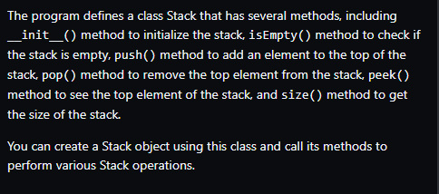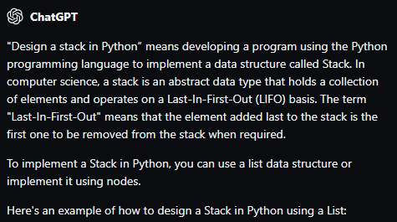

WebEx technical interview.